NB: THE FOLLOWING IS WORK IN PROGRESS. IT WILL BE UPDATED AS INFORMATION COMES TO LIGHT AND WHEN ADDITIONAL RESEARCH IS DONE.
CORONATIONS : BISHOPS OF BATH & WELLS – ATTENDANCE RECORD
HISTORY
A detailed description of the coronation of Richard I (1189) by the chronicler Roger of Wendover, gives us the first documented evidence of the Bishops of Bath and Wells (known as Bishop of Bath at that time), supporting the monarch on the left with Durham on the right, as Bishop Assistants. The chronicler relates: Then came Richard, Duke of Normandy (Richard I), and Hugh, Bishop of Durham, went on his right hand, and Reginald, Bishop of Bath, on his left. [Then follows a description of the service and investiture].
Then the Archbishop put the royal sceptre into his right hand and the royal rod into his left, and thus crowned the king was led to his seat, by the aforesaid Bishops of Durham and Bath, preceded by the torch bearers and the said three swords.
Then was the Mass of Sunday begun; and when they came to the offertory the aforesaid Bishops led him to the altar, and he offered a mark of the purest gold (for this offering which a king must make at every one of his Coronations) and the same Bishops led him back again to his seat.
Now when the Mass had been celebrated and everything duly finished the same two Bishop, one on the right and the other on the left, led him back crowned and carrying the sceptre in his right hand the rod in his left, from the church to his chamber, with the ordered procession going before them as above”.
Appendix I also contains a description of the coronation service of Richard I written by another 12th century chronicler, Roger of Hoveden.
However, it is believed that the Bishop of Bath and Wells (title was Bishops of Wells at the time) played a role in the coronation of Edgar. A chronicler, as reported by Roy Strong in his book – Coronation, A History of the British Monarchy, writes that Edgar ‘convoked all the archbishops, bishops, all great abbots and religious abbesses, all dukes, prefects and judges, and all who had claim to rank and dignity from east to west and north to south over wide lands’ to gather in Bath so ‘that the most reverent bishops might bless, anoint and consecrate him, by Christ’s leave, from whom and by whom the blessed unction of highest blessing and holy religion has proceeded’. Strong goes onto write: ‘The King was led by the hand to the church by two bishop, probably ones representing the northern and southern extremities of his realm, the bishops of Chester-le-Street (later to become the mighty palantine see of Durham) and of Wells’. Rose Longden-Phillips, in her article (Dunstan and Edgar, The Beginnings of the English Coronation, Friends of Wells Cathedral, Journal 2023) proposes that it is the familial ties of Glastonbury and Wells to Edgar and Dunstan, which creates the case for the Bishop of Bath [sic] being one of the two Assistant bishops. As she says: “It would be rather perverse to choose a bishop from another diocese to help the two archbishops at the coronation, when the service is being performed within the diocese of Wells!” The bishop at the time was Cyneweard (he had been a monk at Glastonbury Abbey).
Further written evidence of the Bishop of Bath and Wells supporting the monarch as a Bishop Assistant is in the Liber Regalis: “The bishops of Durham and Bath shall support the king on either side and together with the other bishops shall lead him down the steps of the high altar”.
The Liber Regalis, a beautifully illustrated manuscript, was essentially a ‘how to’ guide on conducting a coronation. Although it was created in 1382, the form of the service as outlined, is believed to have been used in the 1200s.
A story is related here at the Bishop’s Palace that purports to explain how the Bishop of Bath and Wells came to act as one of two supporters to the monarch at their coronation: A monarch (unnamed) stumbled, was prevented from falling by the bishop of Bath and Wells and as a consequence of this the monarch stated that henceforth the Bishop of Bath and Wells would stand on the left side of the monarch at their coronation. No evidence has been found for this story.
COURT OF CLAIMS
The Court of Claims was set up to determine the validity of claims made by individuals claiming the right to undertake certain functions/services/roles at a coronation. It needed to be set up to adjudicate over conflicting claims. The earliest record for the Court of Claims is for the coronation of Richard II, 1377 but possibly existed earlier. If the Court was unable to determine a claim, it would refer it to the sovereign. Records show that Bishops of Bath and Wells have submitted claims in the past and a claim was also submitted for the coronation of Charles III. It is not a ‘done deal’ that the Bishop of Bath and Wells will always serve on the left side of the monarch at a coronation!
MONARCHS – DID THE BISHOPS OF BATH & WELLS TAKE PART IN ALL CORONATIONS FROM EDGAR?
Appendix II shows a table of monarchs starting from Edgar and whether the Bishop of Bath and Wells was present where evidence has been unearthed.
The following provides information relating to those monarchs where it can be shown that the Bishop of Bath and Wells was probably or definitely not present as well as information for some of those monarchs where the bishop was present.
Edward I (1272-1307): William Bitton II was Bishop of Bath and Wells. A memorandum was drawn up few years after Edward’s coronation, naming the bishops and future bishops taking part in the ceremony and the most distinguished magnates present. No details of the form of coronation office used are given. The memorandum does not include the Bishop of Bath and Wells so this would suggest he did not attend. However, Robert Burnell was present and noted as the ‘then Archdeacon of York, and afterwards indeed the Bishop of Bath and Wells’. Burnell was, by this time, very close to Edward.
Henry III (1216-1272): Jocelin was Bishop of Bath and Wells. On the 28 October 1216, Henry, aged 9, was hastily crowned in Gloucester Abbey following the death of his father King John. The political situation at the time was turbulent (the country was in the middle of the Barons War brought about by John’s failure to abide by the Magna Carta) and the French Prince Louis had invaded southern England and even pronounced himself King. There are various sources of information relating to the coronation which differ in which roles were taken on by the participants (see Appendix IV). Jocelin was present at this coronation but his actual role cannot be pinned down definitively. Was he one of two bishops to place the crown on Henry’s head? Did Henry speak the sacred oath to Jocelin? Henry was crowned again 17 May 1220 at Westminster Abbey with full coronation ceremonial. No information has yet come to light on whether Jocelin was present at this second coronation.
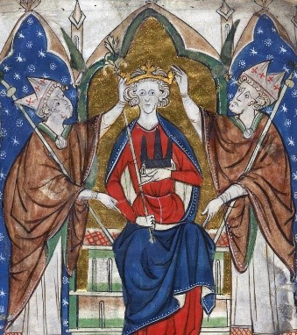
(Source: Cotton Vitellius A. XIII, ref: 14535, British Liibrary. This image may be of Jocelin crowing the King)
William I (1066-87). Roy Strong states that the future king was led by “…the two archbishops. This was different from 973 when Edgar was led by the bishops of Durham and of Bath and Wells, an arrangement which was to appear later”.
Stephen (1135-1154). The See was probably vacant at the time of Stephen’s coronation on the 22 December 1135. Bishop Godfrey had died on the 16th August 1135 and his successor, Robert of Bath/Lewes was, by most accounts on line, was not consecrated until March 1136.
Richard II (1377-1399). John Harewell was Bishop of Bath and Wells. A contemporary report at the time mentions neither the Bishop of Bath and Wells nor the Bishop of Durham being present at the coronation. Furthermore, a report on the submissions to the Court of Claims shows that they did not submit a claim for the right to carry out a duty at Richard’s coronation. This evidence would suggest that Harewell did not play the role of supporter on the left hand of the monarch. It is possible that he was in attendance as the report of the coronation mentions ‘many other prelates and members of the clergy’ being in attendance.
Henry VI (1422-1461). John Stafford was Bishop of Bath and Wells at the time of the coronation. In Gregory’s Chronicle, which gives a detailed account of the coronation, it is stated: “And thenne folowyde the Kynge, and he was ladde by-twyne the Byschoppe of Dyrham and the Byschoppe of Bathe; and my goode Lorde of Warwyke bare uppe his trayne.” Stafford may also been one of the bishops, unnamed, who supported the King bearing the weighty crown : “and thenne sette a yen on hys hedde Synt Edwarde ys crowne, and layde hym a-pon the schaffolde and sette hym a sete of hys astate, and ij byschoppys stondyng on every syde of hym, helpyng hym to bere the crowne, for hyt was ovyr hevy for hym, for he was of a tendyr age”.
Further evidence points to Stafford being present at Henry’s coronation on the 6th November 1429: Stafford’s Register shows that he was in London from April to the end of 1429 and into 1430.Furthermore, Stafford had been a man of state during Henry’s minority (Lord High Treasurer – 1422-1426) and, prior to that, for Henry V he held the post of Lord Privy Seal 1421-22). So, Stafford was well regarded, so much so, that he was appointed Lord Chancellor in 1432, a post he held until 1450.
Stafford is also reported to have attended Henry’s coronation as King of France in 1431

Henry VII (1485-1509). Stillington was Bishop of Bath and Wells (1465-91) at the time of the coronation. However, he was in prison. He had incurred Henry’s wrath. What was the story?
Edward IV married Elizabeth Woodville and had 10 children with her including Edward and Richard – later known as the Princes in the Tower. Stillington is allegedly implicated in making it known that Edward IV had a precontract of marriage to Eleanor Talbot which, in medieval times, effectively made Edward’s marriage to Elizabeth null and void and thus her children illegitimate, and labelled Edward as a bigamist. Richard, the younger brother of Edward IV used this information after Edward IV’s death to announce that he was the rightful heir to the throne and not the’ illegitimate’ son Edward (briefly known as Edward V but never crowned – and believed murdered with his brother in the Tower). Richard’s reign was not long-lasting (1483-85), as he was defeated by Henry Tudor, losing his life in the process which had repercussions for Stillington.
After Henry Tudor VII defeated Richard III at Bosworth in August 1485, he immediately had Stillington imprisoned (with Bishop Foxe – succeeded Stillington as Bp B&W -drawing up the order of arrest). Some say this was due to Stillington's involvement in the matter of Edward IV's supposed bigamy, for the new King needed to reverse these bigamy charges so he could marry his future queen, Elizabeth of York, daughter of Edward IV & Elizabeth Woodville, in order to bring to an end the War of the Roses and unite the Lancastrians and the Yorkists. Henry had the bigamy charge against Edward IV reversed, and married Edward's daughter, Elizabeth of York. Henry VII was crowned on the 30th October 1485. Stillington was still in prison and not released until 2 November 1485; Henry VII pardoned him as a consequence of his 'grete age, long infirmite, and feeblenesse’.
It should be noted that Stillington supported Richard III at his coronation.
(sources: Oxford Dictionary of National Biographies: English Coronation Records, Edited by Leopold G. Wickham Legg, B.A., New College, Oxford Westminster, Publ: Archibald Constable & Co. Ltd. 2. London, 1901, p219
Henry VIII (1509-1547): Hadrian de Costello/Adriano de Castellesi. Research so far suggests that Costello did not support Henry at his coronation. In the Biographical Dictionary Of Italians - Volume 21 (1978), a reputable publication, it is noted that Costello was in Italy over the time when Henry was crowned (24 June, 1509). Costello had appointed Polydor Vergil to act as his proxy as Bishop of Bath and Wells from 1504 and it is possible therefore that Costello did not feel the need to come to England. In fact, he was busy with his political life in Italy.
It is noted in an analysis of Costello’s Register that Costello wrote a congratulatory letter (from Trent (Trento), Italy, dated 3 August 1509) to Henry VIII on his accession and marriage. This would also strongly suggest that Costello had not been present at the coronation in June.
Edward VI (1547-1553): William Knight. Research conducted so far suggests that Knight did not attend Edward’s coronation. In Legg’s Coronation Records he states: “The King's supporters, at least from the time of Richard I., have been the Bishops of Durham and Bath. If either of these is
unable to be present, the King appoints a substitute. Nevertheless at the Court of Claims at Edward VI.'s coronation, judgment was reserved on the claim of these bishops”. Research has not yet uncovered more information about the claim. A further source, which gives a detailed record of the coronation from contemporary manuscripts, states: “The KING'S ROYALL MAJESTIE went under a goodly canapy, borne by the barons of the Cinque Portes, his highnes assysted by th'erle of Shrewesbury [ on his right hand ] , and by the bishop of Durham on the left hand of hym”.

A look at his Register gives no indication of where Knight was over the time of the coronation (there are no entries between 13 January and 28 February 1547. Edward was crowned 20th February 1547, Knight died in September 1947. He was aged 72, so perhaps ill health or old age kept him away?

Mary I (1553-1558): The see was vacant at the time of Mary’s coronation (1 Oct 1553). When Mary ascended the throne in July 1553, she set about re-establishing the Catholic church. It was only a matter of time before the staunch and fervent Protestant Bishop of Bath and Wells, William Barlow, came to her attention. According to The Oxford Dictionary of National Biography, Barlow was committed to the Tower of London on the 16th September 1553, made two unsuccessful attempts to escape, finally recanted to Bishop Gardiner (a Catholic) in January 1555, was released and fled to Europe, where he resumed his protestant faith. Research has so far failed to uncover the precise reason for his imprisonment: some articles state it was because he was married which was not allowed at the time, others because he was a protestant. It is also not clear if he resigned his bishopbric or was deprived when he was thrown into The Tower, but he was no longer bishop at the time of her coronation and was not replaced until 1554 when Gilbert Bourne, the last Catholic bishop of Bath and Wells, was appointed.

Elizabeth I (1558-1603): Bishop Bourne. Evidence points to Bourne not being present at Elizabeth’s coronation. In a commentary on his Register, it is stated that “on the accession of Elizabeth, Gilbert Bourne refused to take the oath acknowledging her supremacy in matters ecclesiastical, and he was committed to the Tower of London”. He was subsequently deprived of the bishopbric sometime between 18th October 1559 and 11th January 1560. His refusal to take the oath was sometime after her coronation (15 January 1559) but given that Bourne was a catholic and Elizabeth’s policy was to remove catholic bishops, would Elizabeth have wanted him taking an active role at her coronation? Elizabeth went on to set up a hierarchy of protestant bishops who were ordained using a Protestant Ordination rite from the Edwardine Ordinal of 1549.
Charles II (1660-85). A detailed account in fifty-two manuscript folios and dated 25 May 1661 of Charles II’s coronation was written by Sir Edward Walker, Garter king of arms. It states the following on page 87: Lastly the Bishops of Duresme and Bath (whose Clayme was allowed to support the King) being called for were placed. See snips below from p 87 and 90 respectively. William Piers was bishop.
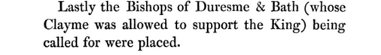
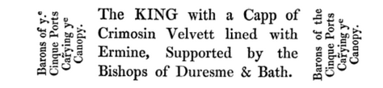

James II (1685-1688). Thomas Ken. Ken assisted at the ceremony – Written in an Account of the time are the words: “Lastly, the Bishop of Durham, and the Bishop of Bath and Wells, are summoned up to support the King, pursuant to ancient Usage […]”. There are 2 images that show Ken standing on the left side of the King: in the procession under the canopy and by the King seated in the Abbey.
William (1689 – 1702) and Mary. There appears to have been just two supporters at the Coronation of William and Mary – these were the Bishops of Winchester and Bristol.
Why did Ken not act as supporter? Ken had been chaplain to Mary in the Hague. He had a poor relationship with William whom he did not respect. Whilst there, Ken had incurred William’s displeasure: Ken didn’t hesitate to speak his mind to William even if it would result in William’s anger and Ken had also arranged the marriage of a high-born English woman to a relative of William’s; this man had initially reneged on his marriage promise. Following the deposition and exile of the catholic king, James II, in 1688, William of Orange, with his wife Mary, ascended the throne. As a condition of office, clergy were required to swear allegiance to the new monarchs but a number refused to do this. “Having sworn an oath of allegiance to James II, they deemed him divinely ordained to office and refused to grant allegiance to those they considered to be usurpers. Some bishops understood the serious consequences of a political vacuum in James's absence—which they refused to equate with abdication—and were willing to grant William and Mary the role of regents, though they refused to recognize their claim to the throne during James's lifetime. To do so would constitute a sinful resistance to the Lord's anointed. Faced with an oath to the new monarchs, nine bishops declined to subscribe.” These individuals were referred to as Nonjurors and Ken was one of these. Along with others, he was suspended from the role of bishop of Bath & Wells in August 1689 and eventually deprived of his bishopbric in 1691.
Mindful, perhaps, of maintaining precedence, Ken had submitted a claim to the Court of Claims for the right to support the King. The Court decided: “It appearing that the Bishop of Bath and Well’s claim had always been joint with the Bishop of Durhan; therefore, as the Bishop of Durham did not now put in his claim, the Commissioners would not give any judgement on the Bishop of Bath and Wells’s separate petition but referred it to the King’s pleasure.” (See Appendix III). We don’t know what William said when he heard of the referral, but given that Ken was a non-juror, it is a reasonable conclusion that William would not have wanted Ken supporting him at his coronation, so refused the application.
Anne (1702-14). Bishop Kidder was bishop of Bath and Wells. An Account of several coronations, including Anne’s, states that the Bishop of Bath and Wells acted as Anne’s supporter, together with the Bishop of Durham. However, an article in the London Gazette makes no mention of the Bishop of Bath and Wells. Instead, it references the Bishops of Durham and Exeter supporting the Queen as she processed into the Abbey under a canopy.
George II (1727-1760). Bishop of St Asaph took the place of the Bishop of Bath and Wells as the See was vacant at the time – Hooper had died Sept 1727 and whilst Wynne had been nominated on the 19th September, he was not confirmed until the 11th November. George’s coronation was in October 1727
George III (1760-1820). Willes was Bishop of Bath and Wells. According to an Account written in 1761, Willes did not attend; it was the Bishop of Lincoln who stood on the left side of the king. See extract below taken from the Account.
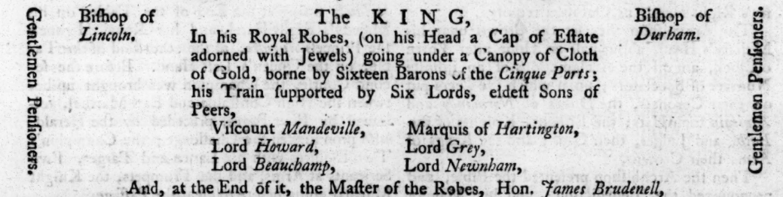
However, The London Gazette, in their report of the Coronation, show the Bishop of Hereford on the left of the King (see extract below)
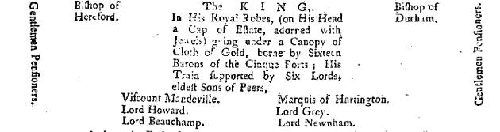

In an article in the Aris's Birmingham Gazette - Monday 28 September 1761 – it is also stated that the Bishop of Hereford stood on the King’s left (see extract below).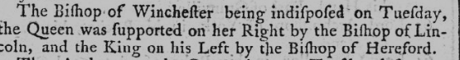
And later in the same article it states that the Bishops of Winchester and Bath & Wells did not attend the coronation as they were indisposed (see extract below)
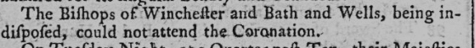
However, in another book which was issued for use (by a member of the Royal Family) at the service on the actual day of the Coronation and is a detailed record of what should take place throughout the coronation, it is clearly stated (p6, p28) that the Bishop of Bath and Wells would support the King on his left side. As the order of service was issued for use on the day it would be reasonably safe to assume that the Bishop of Bath and Wells had submitted his right to participate according to tradition, to the Court of Claims and his claim accepted; the publisher would have had to get the full detail of the service from an authoritative source. However, it appears that on the actual day of the service Bishop Willes was unable to attend due to ill health.
George IV (1820-1830). Beadon was Bishop of Bath and Wells (1802-1824). Beadon petitioned the Court of Claims to establish his right to support the King on his left side; the petition was allowed. However, he also petitioned that he could appoint a deputy to stand in for him due to his great age, which was also allowed. One article stated that the Bishop of St Asaph would stand in for him but later newspaper reports of the actual coronation stated that the Bishop of Oxford took his place. However, a detailed account of the coronation written by Sir George Nayler, (The Coronation of His Most Sacred Majesty King George the Fourth, London, 1839) shows that the Bishop of Lincoln stood in for Beadon and Oxford stood in for Durham.
As a footnote to this story, an article in the Bath Chronicle and Weekly Gazette (Thursday 26 July 1821), reports Beadon and wife putting in an appearance at a dinner put on by the East Wells Benefit Society on the day of the coronation 'and signified their approval at the mirth and general good order which prevailed'.
APPENDIX I

Coronation of Richard I

The following is an extract from ENGLISH CORONATION RECORDS. Edited byLEOPOLD G. WICKHAM LEGG, B.A.,NEW COLLEGE, OXFORD. Publisher - ARCHIBALD CONSTABLE & CO. London 1901……which is a translation of text purported to have been written by the 12th Century chronicler, Roger of Howden or Hoveden (died 1202). PP 51-53

Here beginneth the order of the coronation of Richard, King of England.

First came the bishops and abbots and many clerks vested in silken copes, with the cross, torch bearers, censers, and holy water going before
them, up to the door of the king's inner chamber ; and there they received the said Duke Richard, who was to be crowned, and led him tothe high altar of the church of Westminster with an ordered procession and triumphal chanting : and the whole way by which they went, from the door of the king's chamber to the altar, was covered with woollen cloths.

Now the order of the procession was as follows : at the head came the clerks in vestments carrying holy water, crosses, torches and censers. Then came the priors, then the abbots ; next came the bishops and in the midst of them went four barons carrying four golden candlesticks. Then came Godfrey de Lucy carrying the king's coif, and John Marshal by him carrying two great and weighty golden spurs. Next came William Marshal, Earl of Strigul, carrying the royal sceptre, on the top of which was a golden cross, and William de Patrick, Earl of Salisbury, by his side, bearing a golden rod with a golden dove on the top. Then came David, brother to the King of Scotland, Earl of Huntingdon, and John, Earl of Moreton, brother of the duke, and Robert, Earl of Leicester,
carrying three royal swords taken from the king's treasury, and their scabbards were wholly covered with gold : and the Earl of Moreton went in the midst. Then came six earls and barons carrying on their shoulders a very large board on which were placed the royal ensigns and vestments. Then came William de Mandeville, Earl of Albemarle, carrying a golden crown great and heavy, and adorned on all sides with precious stones. Then came Richard, Duke of Normandy, and Hugh, Bishop of Durham, went on his right hand, and Reginald, Bishop of Bath, on his left : and four barons carried over them a silken canopy on four tall lances : and the whole crowd of earls, barons, knights and others, clerk and lay, followed up to the door of the church, and they came and were brought with the Duke into the choir.

Now when the Duke came to the altar he swore in the presence of the Archbishops, Bishops, clergy and people, on his knees before the altar, and the most holy gospels laid thereon, and the relics of many saints, that he would keep peace, honour and duty towards God and holy church and her customs all the days of his life. Secondly, he swore that he would exercise right justice and equity among the people committed to his charge. Thirdly, he swore that he would annul any evil laws and customs that might have been introduced into the realm, and make good laws and keep them without fraud or evil intent.

Then they stripped him altogether, except his shirt and breeches, and his shirt was torn apart at the shoulders. Then they shod him with buskins worked with gold. Then Baldwin, Archbishop of Canterbury, poured the holy oil on his head and, with prayers appointed for this purpose, anointed him king in three places, to wit, his head, his breast, and his arms, which signifies glory, courage and knowledge. Next the said Archbishop placed on his consecrated head a linen cloth, and above it the coif which Godfrey de Lucy had carried. Then they clothed him with the royal vestments ; first, that is, with the tunic, then with the dalmatic ; then the Archbishop gave him the sword of the realm wherewith he was to repress evildoers against the church. Then two earls put on him the spurs which John Marshal had carried. Then he was vested with the mantle. After that he was led to the altar, and there the said Archbishop forbad him by Almighty God to take this great office upon him, unless he intended to keep inviolate the oaths above mentioned and the vows he had made. And he replied that by the help of God he would keep all the above without deceit. Then he himself took the crown from the altar, and gave it to the Archbishop, and the Archbishop set it on his head, and two earls held it up on account of its weight. Then the Archbishop put the royal sceptre into his right hand and the royal rod into his left, and thus crowned the king was led to his seat, by the aforesaid Bishops of Durham and Bath, preceded by torch bearers and the said three swords. Then was the Mass of the Sunday begun ; and when they came to the offertory the aforesaid Bishops led him to the altar, and he offered a mark of the purest gold (for this is the offering which a king must make at every one of his coronations) and the same Bishops led him back again to his seat.
Now when Mass had been celebrated and everything duly finished the same two Bishops, one on the right and the other on the left, led him back crowned and carrying the sceptre in his right hand and the rod in his left, from the church to his chamber, with the ordered procession going before them as above.

Then the procession returned to the choir, and the lord king laid aside his royal crown and his royal vestments, and put on lighter crowns and vestments, and so crowned he came to breakfast. And the Archbishops and Bishops sat with him at table each according to his degree and rank ; and the earls and barons served in the king's house as their ranks demanded. And the citizens of London served in the butlery, and the citizens of Winchester in the kitchen.

Now the second day after his coronation, Richard, King of England, received the homage and fealty of the Bishops, earls and barons of England : and after this the king put up for sale everything he had, namely, his castles, vills and estates ; whence it came about that Hugh, Bishop of Durham, bought of the king his good manor of Sadberge, with its wapentake and knights' fees, for six hundred marks of silver in pure and perpetual frank almoin, and the king confirmed it by the following charter.

APPENDIX II
SUMMARY TABLE
Following table shows the outcome of research – see key:
- Green text: the names of Bishops definitely confirmed as having supported the monarch at their coronation
- Orange text: the bishops who probably supported the monarch but no written evidence yet found, or evidence inconclusive
- Red text: the bishops where there is a significant reason why, or evidence that, they may not have attended.
- Red shaded cell: shows where the Bishop of Bath and Wells definitely did not support the monarch
- Blank cells: research on-going
- C: = Coronation date

Monarch | Supported by | Monarch | Supported by | Monarch | Supported by
Edgar  (959 – 975)  C: 11/5/973 | Cyneweard of Glastonbury (Bishop of Wells) | Edward The Martyr  (975 – 978)  C: 8/7/975 (possibly) |  | Aethelred II The Unready  (978 – 1016)  C:?
Edmund II Ironside  (1016 – 1016)  C: April 1016 |  | Canute The Dane (1016 – 1035)  C: Jan 1017 |  | HAROLD I  (1035 – 1040)  C: ?
HARTHACANUTE (1040 – 1042)  C: June 1040 |  | EDWARD THE CONFESSOR (1042-1066)  C: 3/4/1043 |  | HAROLD II  (1066 -1066)  C: ?
William I/The Conqueror  (1066- 1087)  C: 25/12/1066 |  | WILLIAM II (Rufus) (1087-1100)  C: 26/9/1087 |  | HENRY I  (1100-1135)  C: 5/8/1100
Stephen  (1135-1154)  C: 22/12/1135 | See vacant | Henry II  (1154-1189)  C: 19/12/1154 |  | Richard I  (1189-1199)  C: 3/9/89 | Reginald Fitz Jocelin
John  (1199-1216)  C: 27/5/1199 |  | Henry III  (1216-1272)  C: 28/10/1216 &  17/5/1220 | Jocelin (28/10/1216) | Edward I  (1272-1307)  C: 19/8/1274)
Edward II  (1307-1327)  C: 25/2/1308 |  | Edward III  (1327-1377)  C: 1/2/1327 |  | Richard II  (1377-1399)  C: 16/7/1377 | John Harewell
Henry IV  (1399-1413)  C: 13/10/1399 |  | Henry V  (1413-1422)  C: 9/4/1413 |  | Henry VI  (1422-1461)  C: 6/11/1429 | John Stafford
Edward IV  (1461-1483)  C:28/6/1461 |  | Richard III  (1483-1485)  C: 6/7/1483 | Stillington | Henry VII  (1485-1509)  C: 13/10/1485
Henry VIII  (1509-1547)  C:24/6/1509 |  | Edward VI  (1547-1553)  C: 20/2/1547 | Knight | Mary  (1553-1558)  C: 1/10/1553 | See vacant
Elizabeth I  (1558-1603)  C: 15/1/1559 | Bourne | James I  (1603-1625)  C: 25/7/1603 | Still | Charles I  (1625-1649)  C: 2/2/1626 | Lake
The Commonwealth (1649-1659) | N/A | Charles II  (1660-1685)  C: 1/1/1661 | William Piers | James II  (1685-1688)  C: 23/4/1685 | Ken
William of Orange (1689-1702)  C: 11/4/1689 | Bishops of Winchester and Bristol (supported both King and Queen) | Anne  (1702-1714)  C: 23/4/1702 | Kidder | George I  (1714-1727)  C: 20/10/1714 | Hooper
George II  (1727-1760)  C: 11/10/1727 | Bishop of St Asaph | George III  (1760-1820)  C: 22/9/1761 | Bishop of Hereford or Lincoln | George IV  (1820-1830)  C: 19/7/1821 | Bishop of Oxford or Lincoln
William IV  (1830-1837)  C: 8/9/1831 | Law | Victoria  (1837-1901)  C:28/6/1838 | Law | Edward VII  (1901-1910)  C: 9/8/1902 | Kennion
George V  (1910-1936)  C: 22/6/1911 | Kennion | Edward VIII  (1936-1936)  Not crowned | N/A. | George VI  (1936-1952)  C: 12/5/1937 | Wynne Willson
Elizabeth II  (1952-2022)  C:2/6/1953 | Bradfield | Charles III  (2022 –  C: 6/5/2023 | Michael Beasley

NB Palace Archives contain information on more ‘recent’ coronations
APPENDIX III

Screen print from: Collections relative to claims at the coronations of several of the kings of England, W. Robinson, 1820 (https://play.google.com/books/reader?id=B0UVAAAAQAAJ&pg=GBS.PR1&hl=en. Accessed 10/04/24)
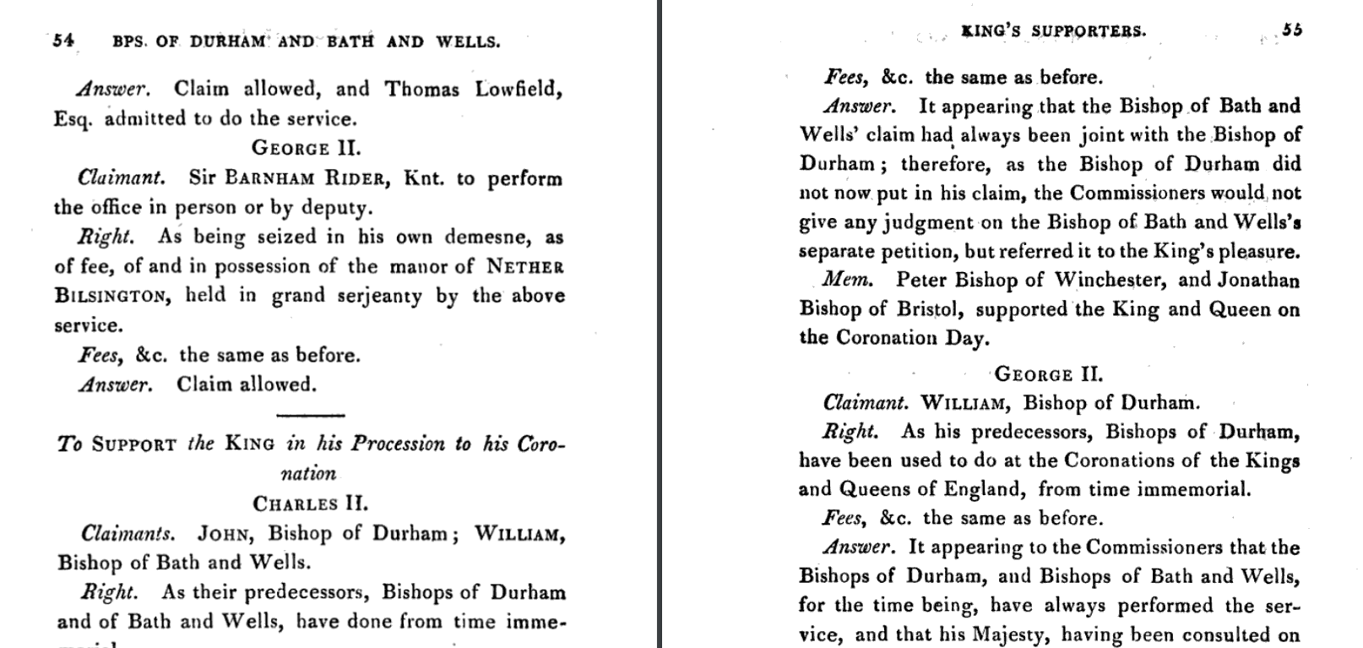

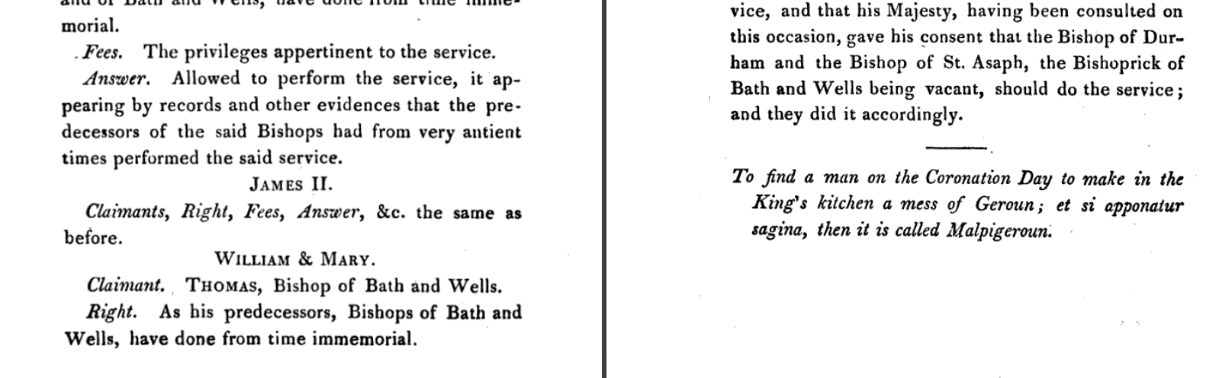

Appendix IV

Coronation of Henry III at Gloucester Cathedral

A number of sources refer to the coronation of Henry III with different accounts of who attended and the roles they played.

The following sources of information have been discovered:

- Matthaei Parisiensis, Monachi Sancti Albani, Chronica Majora, ed. Henry Richards Luard BD, London, 1876, vol 3, pp 1-2.

The following is an extract of the relevant latin text. A Google translation follows

Defuncto Johanne Anglorum rege, convenerunt apud Gloverniam in vigilia Apostolorum Symonis et Judae, in praesentia Walonis apostolicae sedis legatis, Petrus Wintoniensis, Jocelinus Bathoniensis, et Silvester Wigorniensis episcopi, Ranulfus comes Cestrensis, Willelmus Marescallus, comes Penbroc, Willelmius comes de Ferrarrii, Johannes Marescallus, Philipus de Albeneio, cum abbatibus, prioribus, et turba multa nimis […]

Ubi ante majus altare constitutus, dictante sacramentum Jocelino Bathoniensi, juravit coram clero et populo, appositus sibi sancrosanctis Evangeliis et plurimorum sanctorum reliquiis, quod honorem, pacem, ac reverentiam portablit Deo et sanctae ecclesiae et eius ordinatis, omnibus diebus vitae suae. […]

Et his gestis, Petrus Wintoniensis et Jocelinus Bathoniensis episcopi, ipsum in regem unguentes coronaverunt solempniter cum canticis et modulationibus, quae in coronatione regum solent decanter

Translation (Google translate)

After the death of John, king of the English, they assembled at Glovernia on the vigil of the apostles Simon and Judas, in the presence of the ambassadors of the apostolic see of Wallonia, Peter of Winton, Jocelinus of Bath, and Sylvester of Wigornia, the bishop, Ranulf, count of Chester, William the Marshal, the count of Penbroc, William the count of Ferrarri, John the Marshal , Philip of Albeneius, with the abbots, the priors, and a very large crowd [...]

There, having been appointed before the high altar, dictating the sacrament to Jocelinus of Bath, he swore before the clergy and the people, placing before him the holy Gospels and the relics of many saints, that he would bring honor, peace, and reverence to God and the holy church and its ordained, all the days of his life. […]

And with these deeds, the bishops Peter of Winton and Jocelinus of Bath crowned him with perfumes solemnly with the songs and melodies which are usually sung at the coronation of kings.

- The Minority of Henry III, Kate Norgate, Macmillan and Co., Ltd, London. 1912
Kate Norgate states in her book that “Standing before the high altar, he (Henry) recited, under the dictation of the Bishop of Bath, the old traditional coronation oath [….] Bishop Peter of Winchester, assisted by the Bishops of Worcester and Exeter, anointed the child and placed this improvised crown on his head.”(Pages 4/5)
However, she cites several sources of information relating to the coronation in her footnotes. See below.
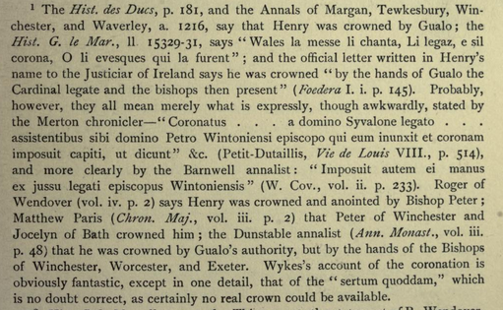

Appendix V

Future sources to explore:
1. National Archives https://discovery.nationalarchives.gov.uk/details/r/C3617.

Records created, acquired, and inherited by Chancery, and also of the Wardrobe, Royal Household, Exchequer and various commissions
Division within C - Records of the Clerk of the Crown and the Crown Office
Catalogue description
Chancery and Lord Chancellor's Office: Crown Office: Coronation Rolls

Reference: C 57
Title: Chancery and Lord Chancellor's Office: Crown Office: Coronation Rolls
Description:
From the early seventeenth century, these rolls provide a record of the accession of the sovereign, followed by a proclamation of the coronation and of the peers' attendance, the appointment of the Court of Claims and the petitions to it (in full) with their answers, a short account of the ceremony with the services performed, and a list by rank of those doing homage.

From 1702 the oath sworn by the sovereign is included as a schedule, and except in the case of George IV, this is signed. Declarations against the transubstantiation of the sacrament and the archbishop of Canterbury's certificate are included from 1714 onwards.

Date: 1308-1954
Related material:
Court of Claims minutes for the twentieth century are in PC 10

There are copies of older coronation claims in SP 9 (https://discovery.nationalarchives.gov.uk/details/r/C13551)

Held by: The National Archives, Kew
Legal status: Public Record(s)
Language: English and French
Physical description: 17 roll(s)
Custodial history: The Coronation rolls for Edward II, Henry IV and Henry V were transferred to the Public Record Office by the Crown Office in accordance with an order of 10 June 1856 which removed them from the Wakefield Tower. At 31 December 1858 the remainder of the rolls then extant were in the Rolls Chapel, their usual repository, whence they subsequently came into the custody of the Public Record Office. From 1685 the rolls end with a memorandum of their transfer to the custody of the Keeper of the Rolls.
Publication note:
Abstracts of some of the records in this series appear in Collections relative to Claims at the Coronations of several of the Kings of England beginning with Richard II (London, 1820). G W Wollaston, Coronation Claims (2nd ed, London, 1910) summarises the claims from 1377 to 1902. Early records, including these, are surveyed by H G Richardson and G O Sayles, 'Early Coronation Records', Bulletin of the Institute of Historical Research, xiii (1935) and xiv (1936). See also, D H Gifford, 'The Coronation in the Public Records', Archives, x (1953).

Administrative / biographical background:
Coronation rolls are drawn up by the clerk of the Crown. All the rolls have in common a recital of claims made (until George II's reign in Law French) to perform services at coronations, and adjudications made on these claims by a Court of Claims set up ad hoc to examine them. Most claimants are entitled by hereditary title, personal or tenurial. There are no rolls for Edward III, Henry VI, Edward IV, Richard III, Henry VII, Henry VIII, Edward VI, Mary, Elizabeth I and Charles I. The only subsequent omission is for George III.

All content is available under the Open Government Licence v3.0,
except where otherwise stated
Version 7.16 - March 2024 – OffSite

APPENDIX V
Other Notes/Research in Progress

Edward II (1307-1327)/Walter Hasleshaw
- There had been a number of different orders of service over the centuries. These were known as recensions. The fourth recension is known to have been used at the coronation of Edward II (1308) but it also predates this but by how many decades is unknown. The Westminster Missal (1383-4) and the Liber Regalis (1382) , both held by Westminster Abbey, contain texts of the Fourth Recension. The Liber Regalis is a detailed guide to how to organise and conduct a coronation. It includes the following detail: The bishops of Durham and Bath shall support the king on either side and together with the other bishops shall lead him down the steps of the high altar. It had been customary for the bishops of Bath and Wells and Durham to act as supporters to the monarch since Richard I’s coronation but the Liber Regalis manuscript names them and specifies their role. Given that the Fourth Recension was relatively ‘new’, could it have been followed to the letter for Edward’s coronation?

Edward III/Drockensford
- Somerset Record Society Calendar of the Register of John de Drokensford, BISHOP OF BATH AND WELLS, (A.D. 1309—1329). Edited from the Original in the Wells Registry BY Right Rev. Bishop Hobhouse, 1887.

No mention is made of the coronation of Edward III 1 February 1327 and the register gives no information on where the bishop was at the time.
Henry IV/ Ralph Erghum
- It is possible that Erghum did not attend the coronation of Henry due to ill-health. It is noted in one article (The Episcopate and The Political Crisis In England of 1386-1388*, Richard G. Davies, Speculum, Vol. 51, No. 4 (Oct., 1976), p.30, accessed via JSTOR), that Erghum “began to ail in the 1390’s”. In his biography in the Oxford Dictionary of National Biography it is noted: “in November 1395 was excused from attending parliament on account of his infirmity”. He died on 10 April 1400, six months after Henry IV’s coronation.
- The Chronicle of Adam Usk provides no information (Given-Wilson, Chris. Ed., The Chronicle of Adam Usk New York: Oxford University Press, 1997)
- The Chronicles of Jean Foissart (Chronicles of England, France, Spain, and the adjoining countries : from the latter part of the reign of Edward II. to the coronation of Henry IV / by Sir John Froissart. Tr. from the French editions ; with variations and additions from many celebrated mss. by Thomas Johnes, esq. To which are prefixed, a life of the author, an essay on his works, and a criticism on his history, Welcome Collection) note only that there were two archbishops and ten bishops officiating at Henry’s consecration; two archbishops and seventeen bishops attended the coronation banquet
- Henry IV, Given-Wilson, Chris – may be worth looking at.

Edward IV/Beckington
- Somerset Record Society, Vol 49, Register of Bishop Bekynton, Part 1.
Edward’s coronation was 28 June 1661. Whilst the register makes no mention of Edward’s coronation, the register shows an entry for 17 June 1661: that “the bishop is prevented from residing in his diocese at present, […] to act as his vicars-general in spirituals during his absence in remote parts…..” (1461, item 1380, pages 359/360)
The next item (1381) for 15 July notes that the bishop is in London (p360)
Item 1382 shows that he is back in Wells (p360)
Could remote parts refer to London or elsewhere?
Anne/Kidder
- Somerset Record Society Vol 34, 1922. The Life of Richard Kidder, autobiography, Edited by Amy Edith Robertson

This is an incomplete autobiography written by Kidder. Some later pages are known to be lost. Anne’s coronation was 23 April, 1702 but there is no reference made about the coronation.

Roy Strong, Coronation, A History of Kingship and the British Monarchy, Harper Collins, 2005, p63
Ibid p66/7
Roy Strong, Coronation, A History of the British Monarchy, Harper Collins, 2022. P 11 (referencing Byrhtferth of Ramsey The Lives of St Oswald and St Ecgwine)
Roy Strong, Coronation, A History of Kingship and the British Monarchy, Harper Collins, 2005, p85,87
Lambeth Palace Library MS. 1212, pp.412-3
Matthæi Parisiensis, monachi Sancti Albani, Chronica majora by Paris, Matthew, 1200-1259; Roger, of Wendover, d. 1236; Luard, Henry Richards, 1825-1891, Longman 1872. See Appendix 4 https://archive.org/details/matthiparisiensi03pari/page/2/mode/2up. accessed 18/07/2024
Ibid p 40
English Coronation Records, Edited by Leopold G. Wickham Legg, B.A., New College, Oxford Westminster, Publ: Archibald Constable & Co. Ltd. 2. London. Pages 150-168.
'Gregory's Chronicle: 1427-1434', in The Historical Collections of a Citizen of London in the Fifteenth Century, (London, 1876) pp. 161-177. British History Online https://www.british-history.ac.uk/camden-record-soc/vol17/pp161-177 [accessed 29 May 2024]https://www.british-history.ac.uk/camden-record-soc/vol17/pp161-177, accessed 29/05/24
The Register of John Stafford, Bishop of Bath and Wells, 1425-1443, Edited by Thomas Scott Holmes, 1915, Vol I, pp69-74
The Coronations of Henry VI, History Today, by Dorothy Styles (Lecturer in History at Birmingham University) & C.T. Allmand (professor of medieval history). https://www.historytoday.com/archive/coronations-henry-vi, accessed 29/05/24
Biographical Dictionary of Italians - Volume 21 (1978). https://www-treccani-it.translate.goog/enciclopedia/adriano-castellesi_%28Dizionario-Biografico%29/?_x_tr_sl=it&_x_tr_tl=en&_x_tr_hl=en&_x_tr_pto=sc&_x_tr_hist=true Accessed 25/04/24
The Registers of Oliver King, Bishop of Bath and Wells, 1496-1503, and Hadrian de Castello, Bishop of Bath and Wells, 1503-1518, Edited by Sir Henry Maxwell-Lyte, 1939, Somerset Record Society, Vol 54, p xix
English Coronation Records, Edited by Leopold G. Wickham Legg, B.A., New College, Oxford Westminster, Publ: Archibald Constable & Co. Ltd. 2. London, 190. Page lxix
Literary remains of King Edward the Sixth, Volume I, Edited from His Autograph Manuscripts, with Historical Notes and a Biographical Memoir. Editor, John Gough Nichols. Publisher, B. Franklin, 1857. P ccxciii. https://books.googleusercontent.com/books/content?req=AKW5QaeQcLRQdlMNRh586QZ0FVI3h6rFWlYGIKITRo-0b4LlEMdoNL-uZpBcknb_0kMkMRzYgYwBkWfVnyot0PNZ4ZYQbZAp4BkPqwqTLjpPbENCSqtJh8KbT9EK6Fv3IJkmgJZ6ZE2OIdNLqQ8w9bZ1kAA20nXgwYeQGUptAXmdNvBA0UrPx39svvgVTJdEwQ4nl02VwWPTRSzm95XPRyFZKj_WmQgzDjivigJuKPoKCqdvWj5iNpFRIM0Ihi2cHrCKsKLQvxzb4WEJXfHdtfppA4scFaW5s13gQlrUMLZhRprksUk7jEI. Accessed 25/04/24
The Registers of Thomas Wolsey, John Clerke, William Knyght and Gilbert Bourne, Edited by Sir Henry Maxwell-Lyte, K.C.B., Somerset Record Society , Vol 55, 1940
The Registers of Thomas Wolsey, John Clerke, William Knyght and Gilbert Bourne, Edited by Sir Henry Maxwell-Lyte, K.C.B., Somerset Record Society , Vol 55, 1940, p xvi
A Circumstantial account of the preparations for the coronation of His Majesty King Charles the Second and a minute detail of that splendid ceremony ... To which is prefixed, an account of the landing, reception, and journey of His Majesty from Dover to London. From an original manuscript, by Sir Edward Walker, Knight, Garter Principal King at Arms at that period. https://www.google.co.uk/books/edition/A_Circumstantial_Account_of_the_Preparat/flUdZlt6KogC?hl=en&gbpv=1&printsec=frontcover. Accessed 14/3/24
An Account of the Ceremonies Observed at the Coronation of Our Most Gracious Sovereign III and his Royal Consort Queen Charlotte… (London: G. Kearsley [1761. P13. https://archive.org/details/bim_eighteenth-century_an-account-of-the-ceremo_1761/page/n11/mode/2up. Accessed 06/03/24
A Description of the Ceremonial Proceedings at the Coronation of their Most Sacred Majesties, King WILLIAM III. and Queen MARY II. Who were Crowned at Westminster-Abby, on Thursday the 11th. of April, 1689. London: printed by George Croom at the Blue-Ball in Thames-street, near Baynard's-Castle, 1689 – the original is kept in the Bodleian Library) https://quod.lib.umich.edu/e/eebo2/A35766.0001.001/1:1?rgn=div1;view=fulltext.
Oxford Dictionary of National Biography. https://www.oxforddnb.com/display/10.1093/ref:odnb/9780198614128.001.0001/odnb-9780198614128-e-47712, accessed 14 Dec 2023.
Collections relative to claims at the coronations of several of the kings of England, W. Robinson, 1820 (https://play.google.com/books/reader?id=B0UVAAAAQAAJ&pg=GBS.PR1&hl=en. Accessed 10/04/24)
An Account of the Ceremonies Observed at the Coronation of Our Most Gracious Sovereign III and his Royal Consort Queen Charlotte… (London: G. Kearsley [1761]. P31. https://archive.org/details/bim_eighteenth-century_an-account-of-the-ceremo_1761/page/n35/mode/2up. Accessed 06/03/24
https://www.thegazette.co.uk/London/issue/3804/page/1/. Accessed 06/03/24
An Account of the Ceremonies Observed at the Coronation of Our Most Gracious Sovereign III and his Royal Consort Queen Charlotte… (London: G. Kearsley [1761]
https://www.thegazette.co.uk/London/issue/10142/page/1/. Accessed 06/03/24
Aris's Birmingham Gazette - Monday 28 September 1761
The form and order of the service that is to be performed, and of the ceremonies that are to be observed, in the coronation of their Majesties King George III. and Queen Charlotte, ... 22d of September, 1761. London : Mark Baskett and the Assigns of Robert Baskett. https://archive.org/details/bim_eighteenth-century_the-form-and-order-of-th_church-of-england_1761/page/5/mode/2up. Accessed 06/03/24
English Coronation Records, Edited by Leopold G. Wickham Legg, B.A., New College, Oxford Westminster, Publ: Archibald Constable & Co. Ltd. 2. London, 1901, p354
English Coronation Records. Edited by Leopold G. Wickham Legg, B.A.,New College, Oxford. Publisher - Archibald Constable & Co. London 1901 p 51
English Coronation Records. Edited by Leopold G. Wickham Legg, B.A.,New College, Oxford. Publisher - Archibald Constable & Co. London 1901 p 196 (His source is quoted as Bodl. Ashm. MS. 863)
Coronation A History of the British Monarchy, Roy Strong, Harper Collins, 2022, p206
Coronation A History of the British Monarchy, Roy Strong, Harper Collins, 2022, p201
https://www.thegazette.co.uk/London/issue/5270/page/1. Accessed 06/03/24
An Account of the Ceremonies Observed at the Coronation of Our Most Gracious Sovereign III and his Royal Consort Queen Charlotte… (London: G. Kearsley [1761]. . P35. https://archive.org/details/bim_eighteenth-century_an-account-of-the-ceremo_1761/page/n33/mode/2up. Accessed 06/03/24
An Account of the Ceremonies Observed at the Coronation of Our Most Gracious Sovereign III and his Royal Consort Queen Charlotte… (London: G. Kearsley [1761]. P40. https://archive.org/details/bim_eighteenth-century_an-account-of-the-ceremo_1761/page/n39/mode/2up. Accessed 06/03/24
The London Gazette, 13 September 1831, Issue 18848, p 1866. . https://www.thegazette.co.uk/London/issue/18848/page/1861.Accessed 02/05/24
Various sources
(https://archive.org/details/minorityofhenryt00norguoft/page/n1/mode/2up. accessed 11/12/2024)

